THE INTERNATIONAL UNIVERSITY (IU)
VIETNAM NATIONAL UNIVERSITY - HCMC
assignment
SUBJECT: PHYSICS 4
GROUP: 3 –5 STUDENTS
(To submit the 17th JULY 2014)
Student Name:_______________________Student ID:___________________

Fig. 1
θ₁
θ₂
v₁
v₂
h₁
h₂
x
l
A
B
I
Question 1 (25 marks) A ray of light goes from point A in a medium in which the speed of light is v₁, to point B in a medium in which the speed is v₂ (Fig. 1). The ray strikes the interface at the point I to the right of point A.
(a) Show that the time required for the light to go from A to B is
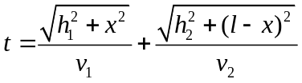.
(b) Use Fermat's principle of least time to find Snell’s law (law of refraction).
Question 2 (25 marks) The wavefunction of a particle is given as: 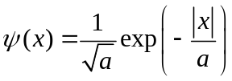. Calculate the probability that this particle will be found outside the Bohr radius a.
Question 3 (25 marks) An object 8.0 cm high is placed 12.0 cm to the left of a converging lens of focal length 8.0 cm. A second converging lens of focal length 6.0 cm is placed 36.0 cm to the right of the first lens. Both lenses have the same optic axis. Find the position, size, and orientation of the final image produced by the two lenses in combination.
Question 4 (25 marks) A particle is in the ground level of a box that extends from x = 0 to x = L.
(a) What is the probability of finding the particle in the region between 0 and L/4?
(b) What is the probability of finding the particle in the region x = L/4 to x = L/2?
(c) How do the results of parts (a) and (b) compare? Explain.
(d) Add the probabilities calculated in parts (a) and (b). Explain the result.

The end

